TEST SCENARIOS

|  |  |  |
| --- | --- | --- |
| 1 | PO | Req creation 🡪 Req Approval (Done-SP1->TC11) |
| 2 | PO | Blanket Release creation from PR 🡪 Blanket Release Approval |
| 3 | PO | Standard PO creation from PR 🡪 PO Approval |
| 4 | PO | PO Receipt creation |
| 5 | PO | Invoice creation |
| 6 | PO | Assign a Buyer to an Approved Requisition where the Buyer is unavailable |
| 7 | PO | Change the Buyer on an Approved Requisition (Done-SP1🡪TC17) |
| 8 | PO | Return to Supplier |
| 9 | PO | Global Blanket Agreement Creation 🡪 Approval |

1. Requisition creation 🡪 Req Approval

User- BRAHMEG

Responsibility – MWSPC Purchasing Power Generation

Purchasing Preparer 🡪 Requisitions

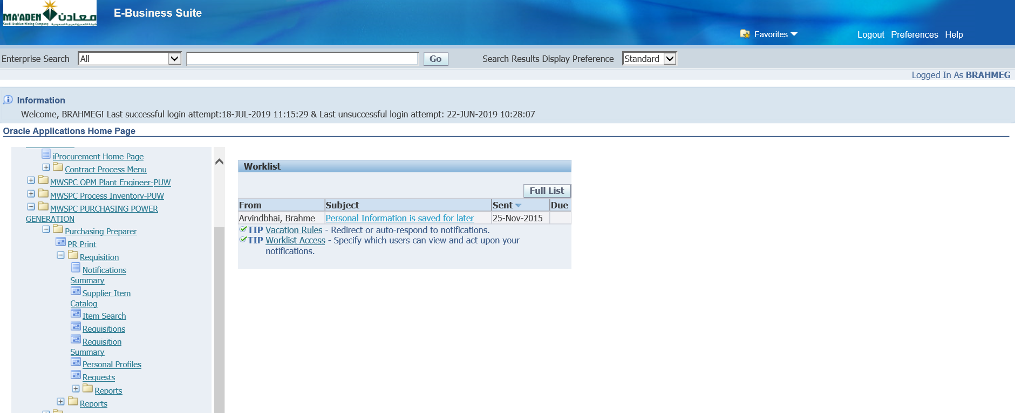

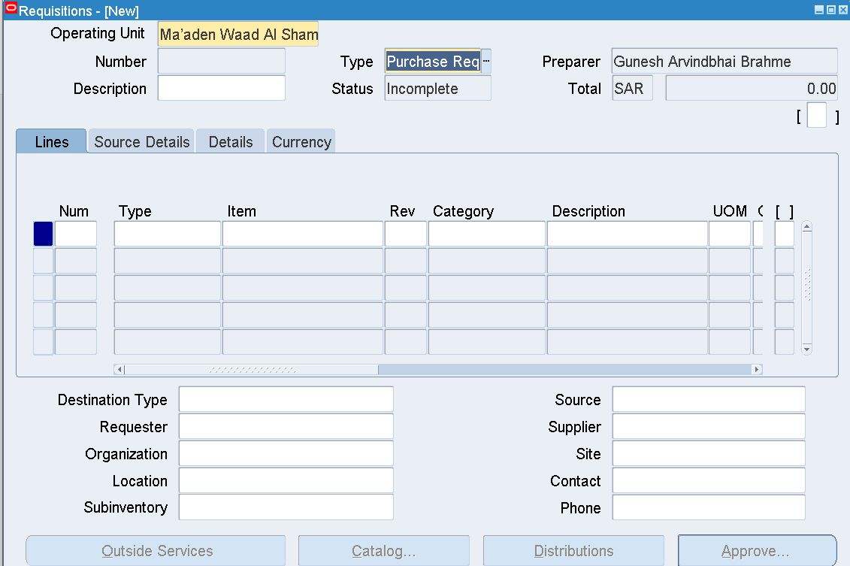

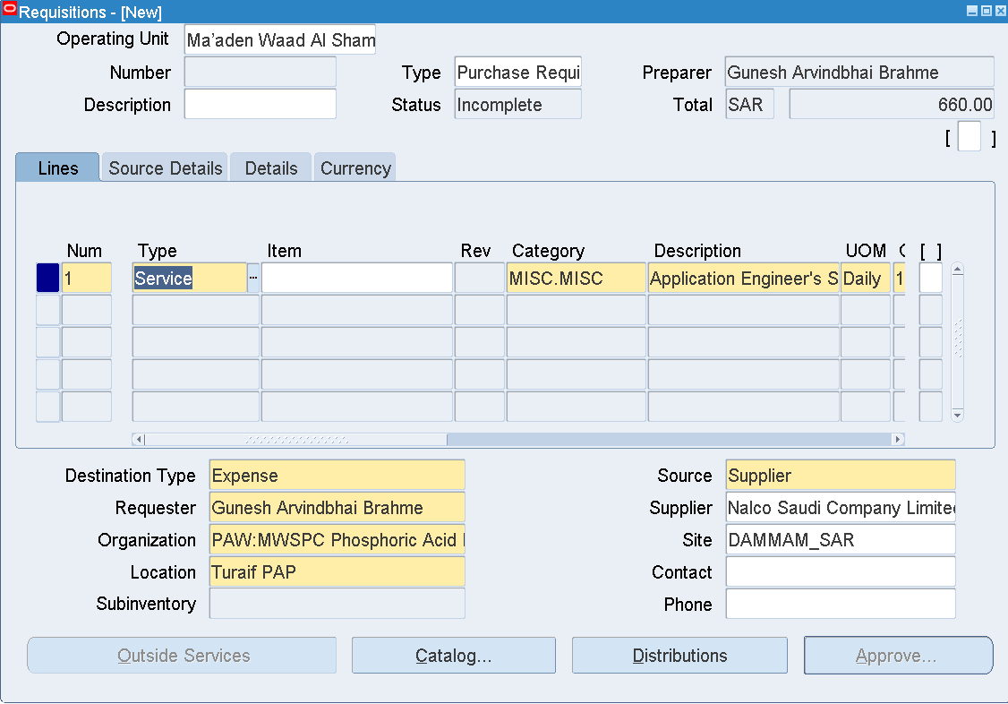

|  |  |
| --- | --- |
| Type | Service |
| Category | MISC.MISC |
| Description | Application Engineer's Service Charge |
| UOM | Daily |
| Quantity | 1 |
| Price | 660 |
| Need by Date | Any future date |
| Organization | PAW:MWSPC Phosphoric Acid Plant Warehouse |
| Location | Turaif PAP |
| Supplier | Nalco Saudi Company Limited |
| Site | DAMMAM_SAR |
| Source Details |  |
| Document Type | Blanket Purchase Agreement |
| Document | 741700202 |
| Line | 13 |

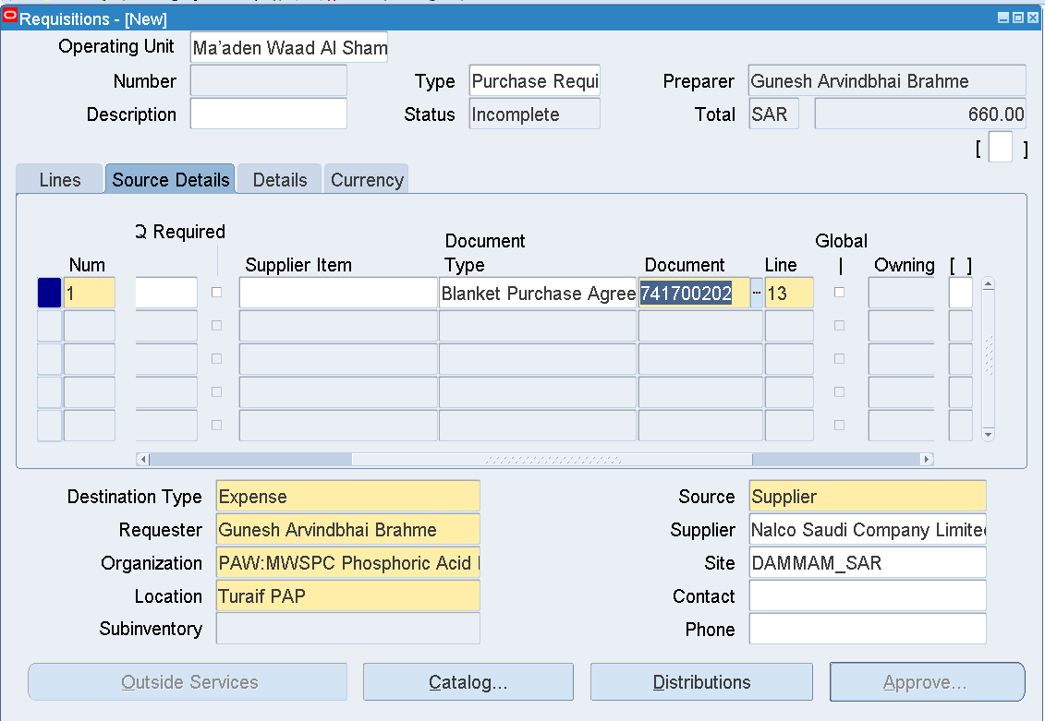

Save

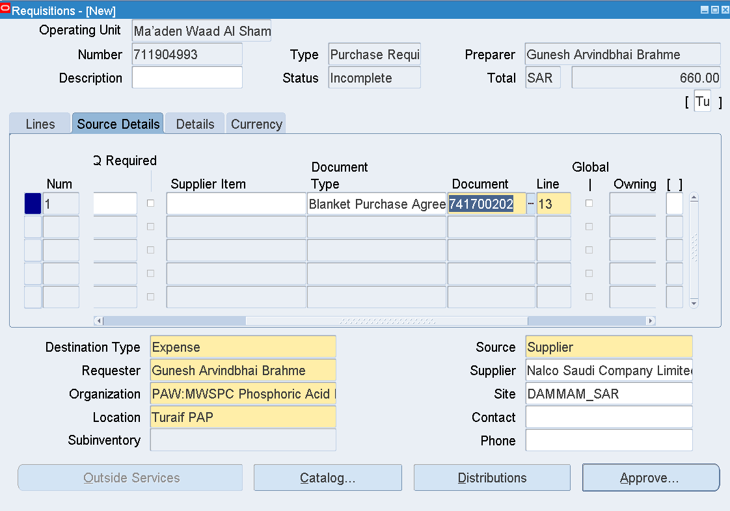

Requisition number 711904993 is generated

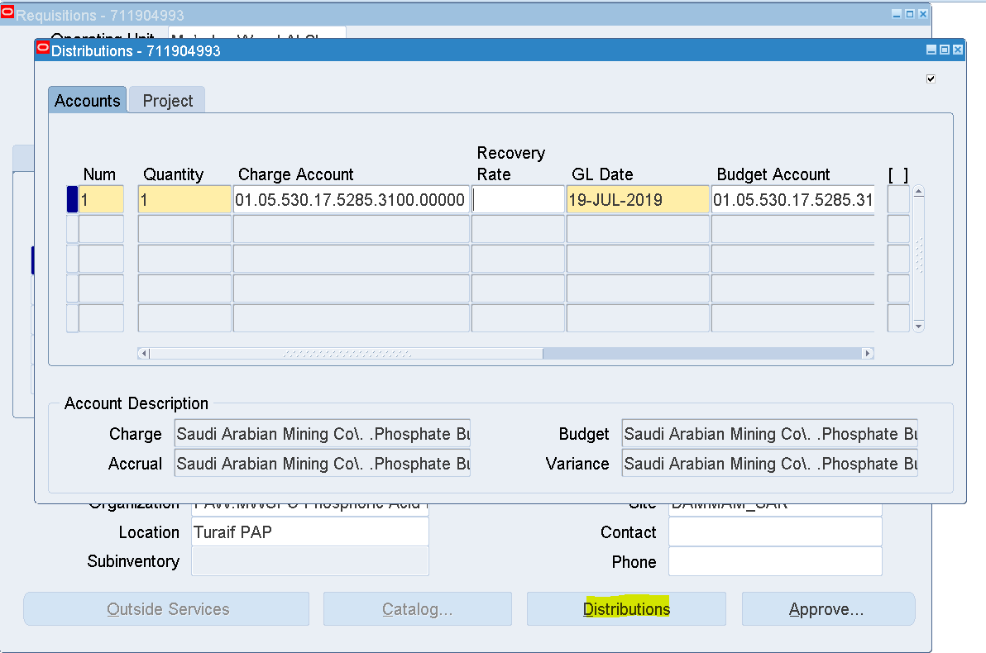

Distributions

Enter Charge Account - 01.05.530.17.5285.3100.00000

Save

Approve

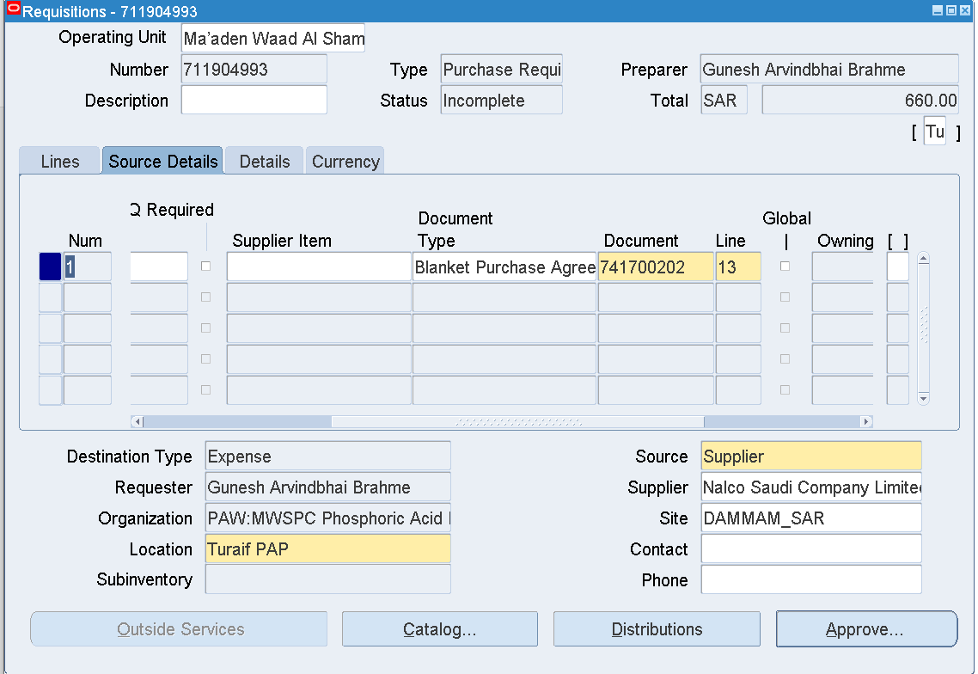

Approve

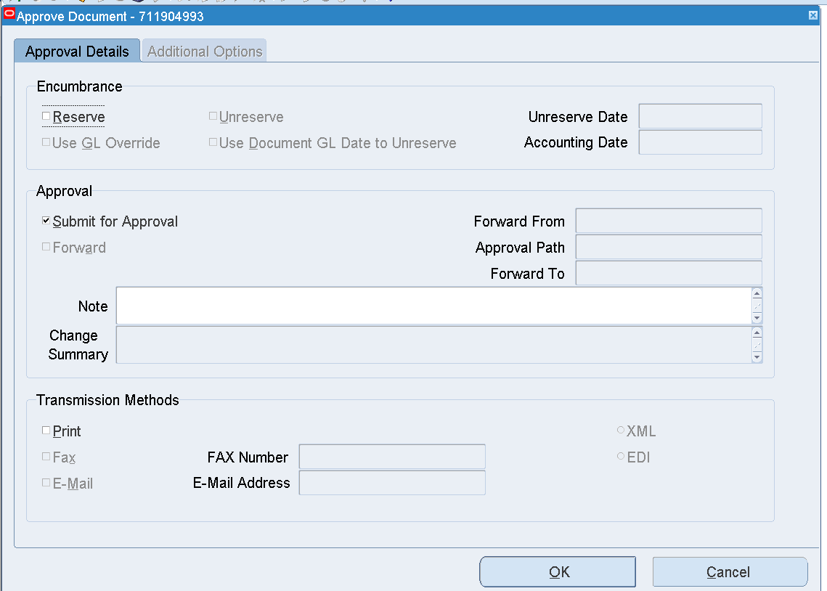

OK

Requisition – 711904993

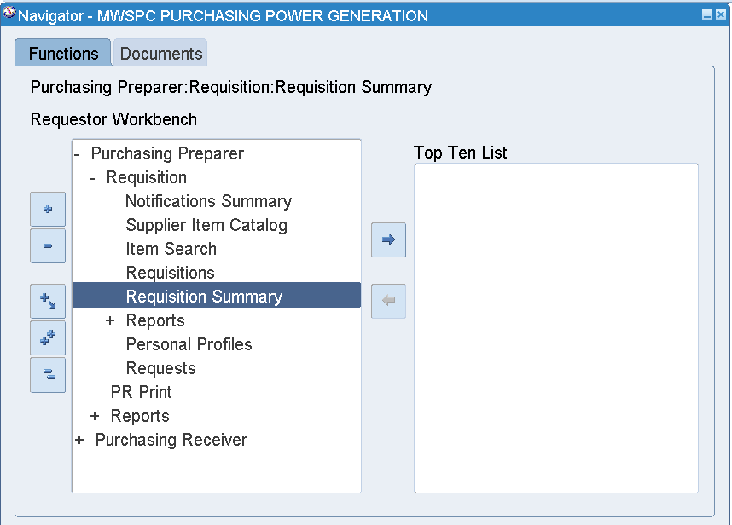

Requisition Summary

Enter Requisition Number 711904993

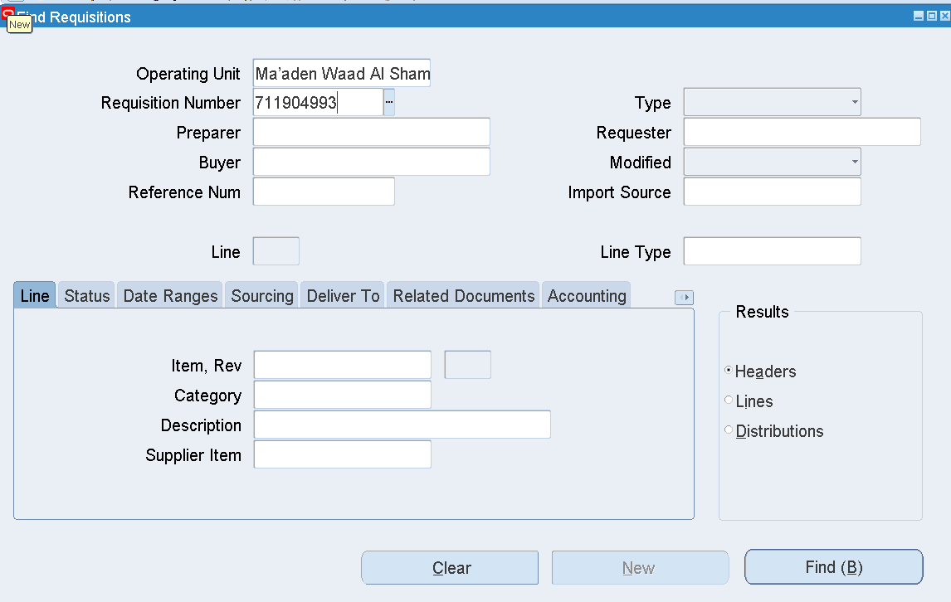

Find

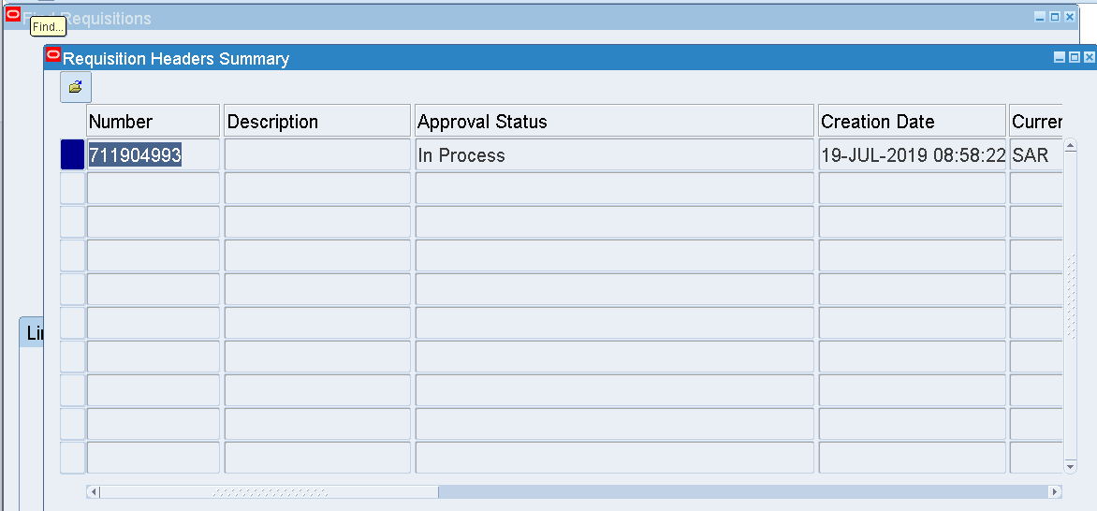

Approval Status 🡪 In Process

Tools 🡪 View Action History

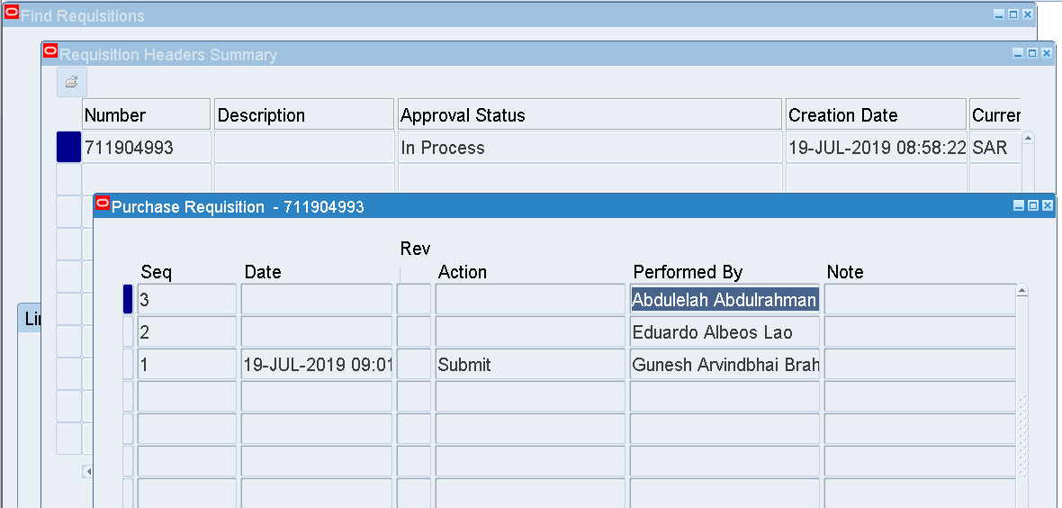

Approver - Abdulelah Abdulrahman Mohammed Alameri

Abdulelah Abdulrahman Mohammed Alameri’s User name – ALAMERIA

Login as ALAMERIA

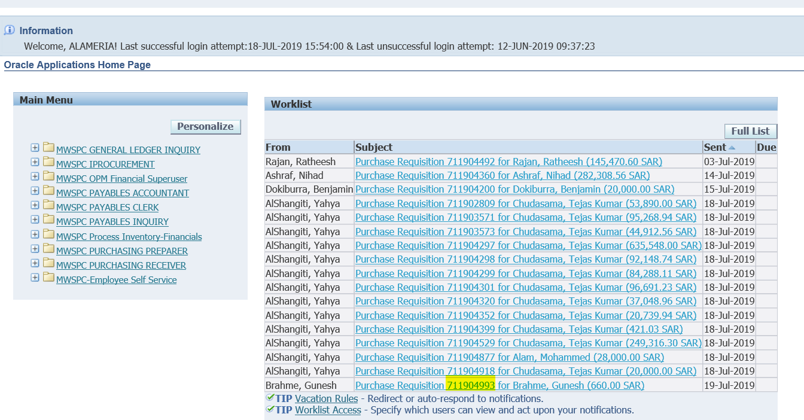

The Requisition is available in the Worklist

And awaiting Approval

Select that Link

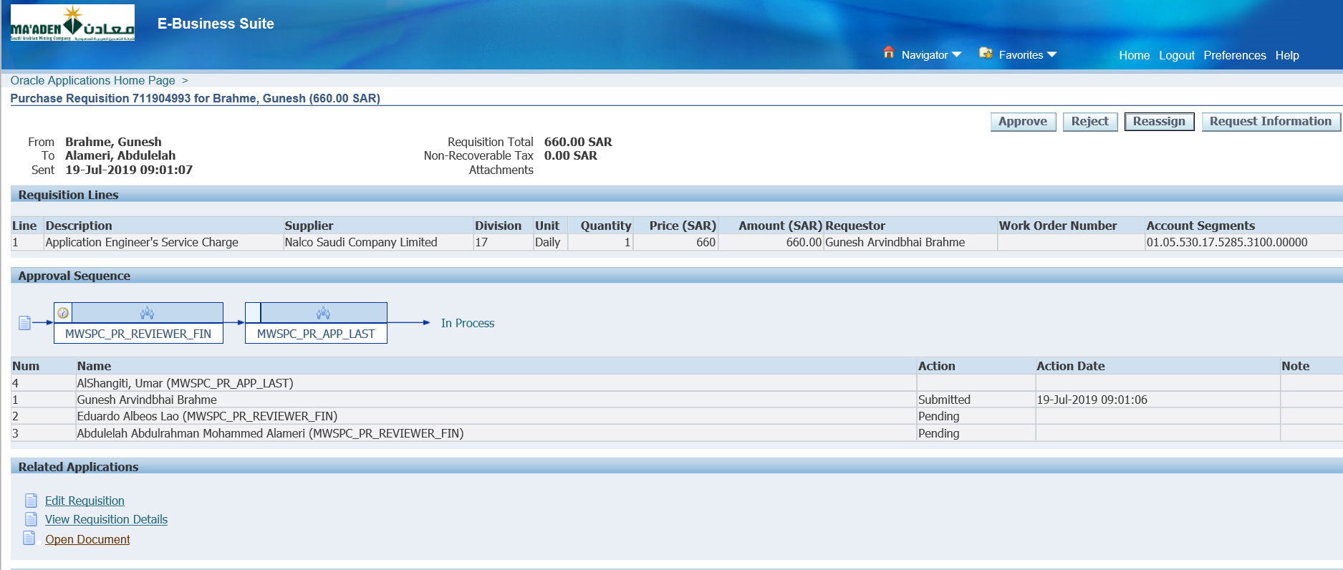

Click Approve

Then Login as Umar Khatri AlShangiti

User - SHANGITIU

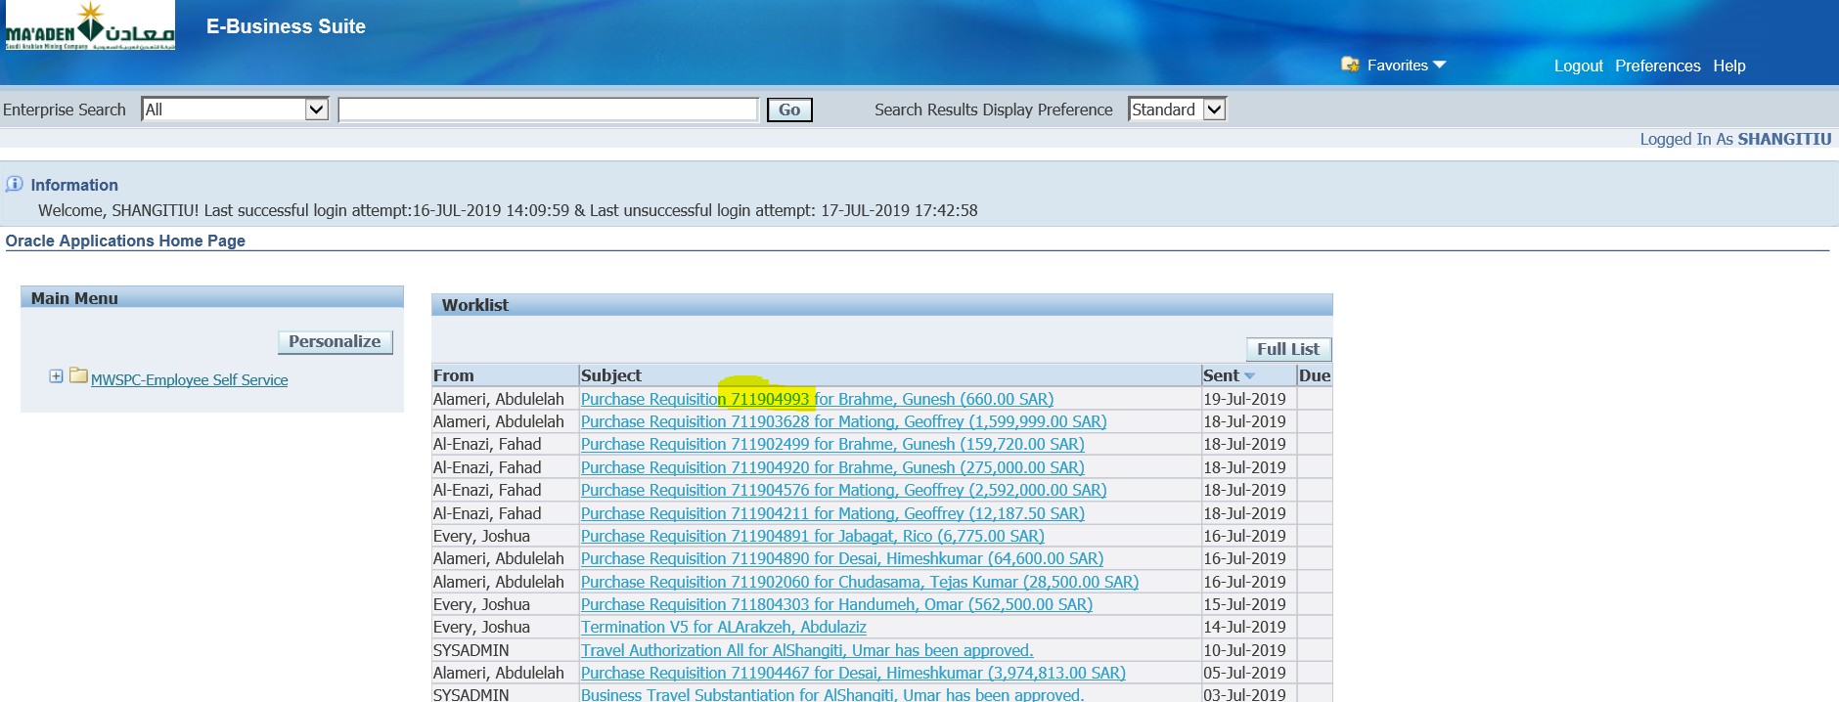

Open that Requisition from the worklist

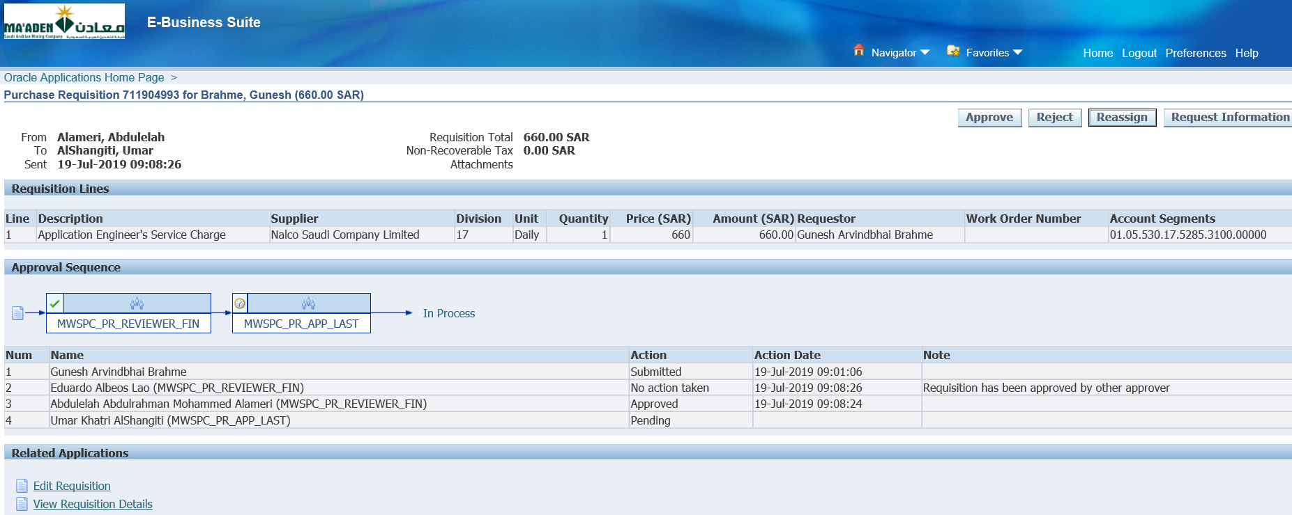

Click Approve

Once this is Approved